Supplementary information
This file include:
- Tables with median anual data on erosion, deposition, migration, and morphometric parameters.
- A comparative graph of erosion and deposition, classified by subperiods, which facilitates the visualization of temporal trends.
- A catalog of Landsat satellite images used in the research, indicating the years and scenes used in the multitemporal analysis.

Average width

ASGM-impact period | Year | Section A1 | Section A2 | Section A3 | Total
Minimal mining | 1984 | 115.7 | 114.5 | 164.9 | 131.7
 | 1987 | 147.1 | 129.8 | 182.4 | 153.1
 | 1992 | 146.0 | 125.7 | 179.0 | 150.2
 | 1996 | 110.1 | 122.1 | 163.9 | 132.0
 | 2000 | 157.1 | 147.8 | 186.3 | 163.7
 | Median per period | 146.0 | 125.7 | 179.0 | 150.2
Moderate mining | 2004 | 116.8 | 144.0 | 183.2 | 148.0
 | 2008 | 142.3 | 191.9 | 184.7 | 173.0
 | Median per period | 129.5 | 168.0 | 184.0 | 160.5
Intensive mining | 2012 | 155.3 | 182.6 | 192.2 | 176.7
 | 2016 | 176.6 | 190.5 | 187.6 | 184.9
 | 2020 | 158.5 | 191.5 | 180.0 | 176.7
 | Median per period | 158.5 | 190.5 | 187.6 | 178.9
Total |  | 143.0 | 155.7 | 181.1 | 160.0
Table 1. Average width medians per period and sub-periods

Erosion and deposition
ASGM-impact Period | Sub-period | Erosion (ha) |  |  | Deposition (ha)
 |  | A1 | A2 | A3 | A1 | A2 | A3
Minimal mining | 1984-1987 | 206.4 | 245.8 | 217.4 | 62.4 | 116.7 | 95.5
 | 1987-1992 | 162.5 | 245.3 | 186.3 | 212.9 | 264.4 | 205.3
 | 1992-1996 | 99.4 | 188.6 | 96.8 | 171.3 | 261.8 | 189.1
 | 1996-2000 | 183.3 | 247.6 | 260.9 | 79.2 | 195.7 | 64.5
Moderate mining | 2000-2004 | 155.4 | 222.3 | 184.8 | 143.1 | 365.0 | 169.2
 | 2004-2008 | 114.9 | 393.8 | 145.0 | 106.7 | 117.3 | 139.8
Intensive mining | 2008-2012 | 142.1 | 254.7 | 255.2 | 122.7 | 193.3 | 140.5
 | 2012-2016 | 224.3 | 294.7 | 215.9 | 191.8 | 365.7 | 203.2
 | 2016-2020 | 180.3 | 299.0 | 195.0 | 240.0 | 438.8 | 275.1
Table 2. Erosion and deposition areas (ha) per sub-periods and river section.
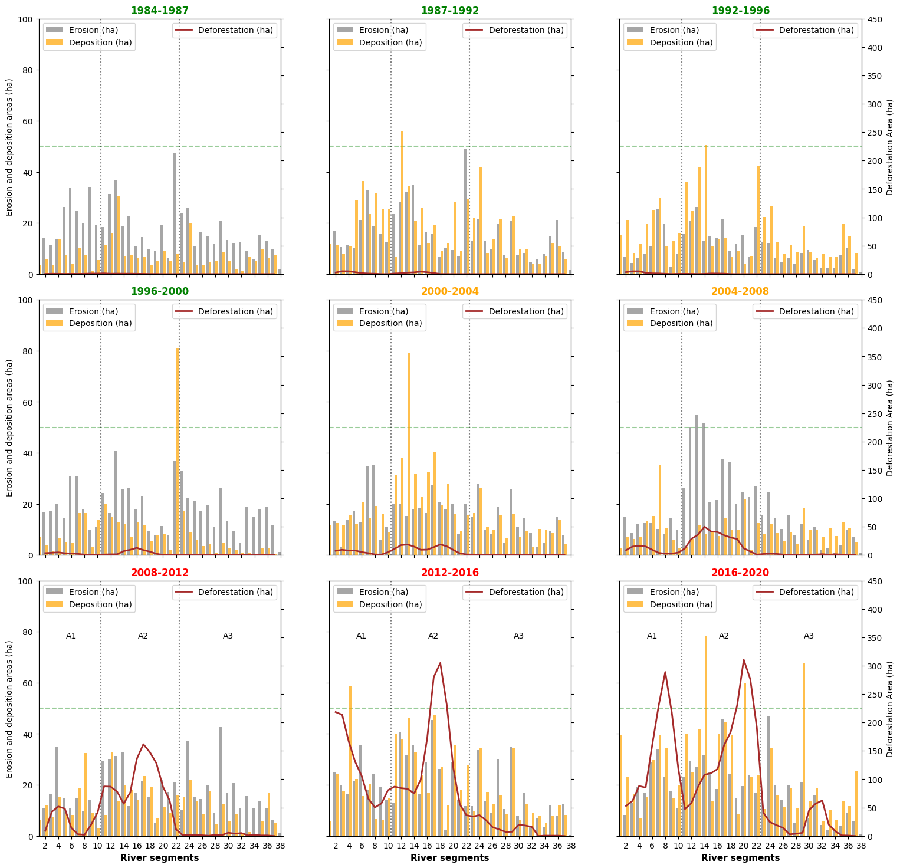
Figure 1. Erosion and deposition areas (ha) per sub-periods and river section.
Migration

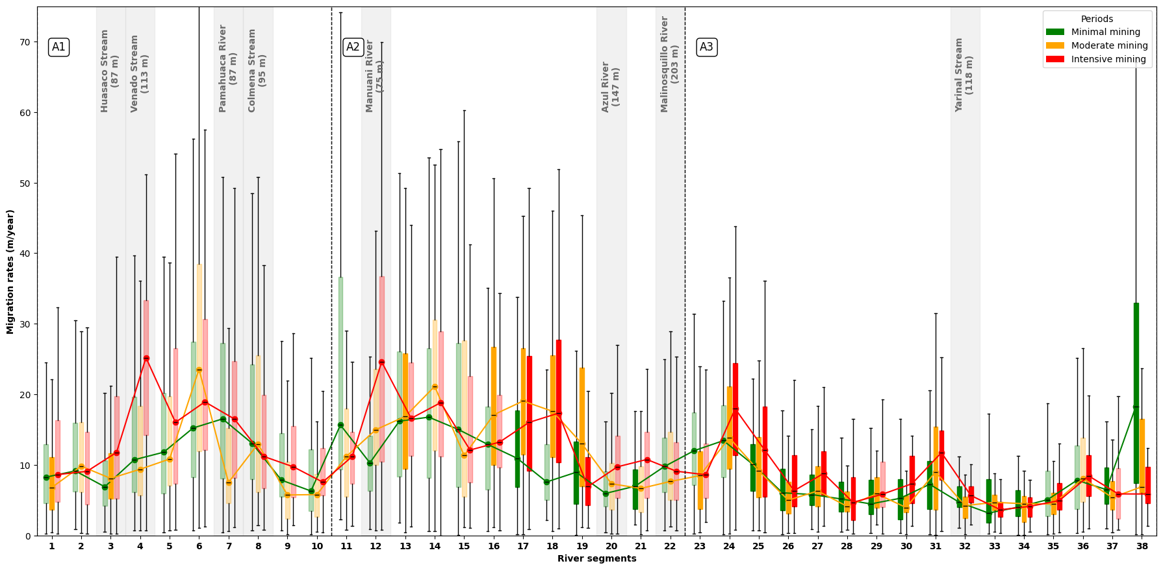
Figure 2. Migration rates of the Malinowski River across segments in sections A1, A2 and A3 during the three mining periods (minimal, moderate and intensive activity). Colored boxplots represent the average rate per period, with transparent boxplots indicating the presence of secondary channels. The green boxplots and curves can be considered pristine conditions (unaffected by mining). Shaded areas mark the confluence with tributary rivers.

Satellite images catalog
Year | ID | Satellite | Path | Row | Date of acquisition
1984 | LT05_002069_19840426 | Landsat 5 | 002 | 069 | 4/26/1984
1984 | LT05_002069_19840901 | Landsat 5 | 002 | 069 | 9/1/1984
1984 | LT05_003069_19840620 | Landsat 5 | 003 | 069 | 6/20/1984
1984 | LT05_003069_19840706 | Landsat 5 | 003 | 069 | 7/6/1984
1984 | LT05_003069_19840722 | Landsat 5 | 003 | 069 | 7/22/1984
1984 | LT05_003069_19840807 | Landsat 5 | 003 | 069 | 8/7/1984
1984 | LT05_003069_19841010 | Landsat 5 | 003 | 069 | 10/10/1984
1987 | LT05_002069_19870302 | Landsat 5 | 002 | 069 | 3/2/1987
1987 | LT05_002069_19870318 | Landsat 5 | 002 | 069 | 3/18/1987
1987 | LT05_002069_19870521 | Landsat 5 | 002 | 069 | 5/21/1987
1987 | LT05_002069_19870622 | Landsat 5 | 002 | 069 | 6/22/1987
1987 | LT05_002069_19870708 | Landsat 5 | 002 | 069 | 7/8/1987
1987 | LT05_002069_19870724 | Landsat 5 | 002 | 069 | 7/24/1987
1987 | LT05_002069_19870809 | Landsat 5 | 002 | 069 | 8/9/1987
1987 | LT05_002069_19870825 | Landsat 5 | 002 | 069 | 8/25/1987
1987 | LT05_002069_19870926 | Landsat 5 | 002 | 069 | 9/26/1987
1987 | LT05_002069_19871012 | Landsat 5 | 002 | 069 | 10/12/1987
1987 | LT05_003069_19870309 | Landsat 5 | 003 | 069 | 3/9/1987
1987 | LT05_003069_19870325 | Landsat 5 | 003 | 069 | 3/25/1987
1987 | LT05_003069_19870410 | Landsat 5 | 003 | 069 | 4/10/1987
1987 | LT05_003069_19870426 | Landsat 5 | 003 | 069 | 4/26/1987
1987 | LT05_003069_19870512 | Landsat 5 | 003 | 069 | 5/12/1987
1987 | LT05_003069_19870613 | Landsat 5 | 003 | 069 | 6/13/1987
1987 | LT05_003069_19870629 | Landsat 5 | 003 | 069 | 6/29/1987
1987 | LT05_003069_19870816 | Landsat 5 | 003 | 069 | 8/16/1987
1987 | LT05_003069_19870901 | Landsat 5 | 003 | 069 | 9/1/1987
1992 | LT05_002069_19920331 | Landsat 5 | 002 | 069 | 3/31/1992
1992 | LT05_002069_19920416 | Landsat 5 | 002 | 069 | 4/16/1992
1992 | LT05_002069_19920619 | Landsat 5 | 002 | 069 | 6/19/1992
1992 | LT05_002069_19920705 | Landsat 5 | 002 | 069 | 7/5/1992
1992 | LT05_002069_19920721 | Landsat 5 | 002 | 069 | 7/21/1992
1992 | LT05_002069_19920806 | Landsat 5 | 002 | 069 | 8/6/1992
1992 | LT05_002069_19920907 | Landsat 5 | 002 | 069 | 9/7/1992
1992 | LT05_002069_19920923 | Landsat 5 | 002 | 069 | 9/23/1992
1992 | LT05_002069_19921025 | Landsat 5 | 002 | 069 | 10/25/1992
1992 | LT05_003069_19920322 | Landsat 5 | 003 | 069 | 3/22/1992
1992 | LT05_003069_19920423 | Landsat 5 | 003 | 069 | 4/23/1992
1992 | LT05_003069_19920509 | Landsat 5 | 003 | 069 | 5/9/1992
1992 | LT05_003069_19920610 | Landsat 5 | 003 | 069 | 6/10/1992
1992 | LT05_003069_19920626 | Landsat 5 | 003 | 069 | 6/26/1992
1992 | LT05_003069_19920813 | Landsat 5 | 003 | 069 | 8/13/1992
1992 | LT05_003069_19920914 | Landsat 5 | 003 | 069 | 9/14/1992
1992 | LT05_003069_19920930 | Landsat 5 | 003 | 069 | 9/30/1992
1996 | LT05_002069_19960310 | Landsat 5 | 002 | 069 | 3/10/1996
1996 | LT05_002069_19960427 | Landsat 5 | 002 | 069 | 4/27/1996
1996 | LT05_002069_19960513 | Landsat 5 | 002 | 069 | 5/13/1996
1996 | LT05_002069_19960529 | Landsat 5 | 002 | 069 | 5/29/1996
1996 | LT05_002069_19960614 | Landsat 5 | 002 | 069 | 6/14/1996
1996 | LT05_002069_19960630 | Landsat 5 | 002 | 069 | 6/30/1996
1996 | LT05_002069_19960716 | Landsat 5 | 002 | 069 | 7/16/1996
1996 | LT05_002069_19960801 | Landsat 5 | 002 | 069 | 8/1/1996
1996 | LT05_002069_19960817 | Landsat 5 | 002 | 069 | 8/17/1996
1996 | LT05_002069_19960902 | Landsat 5 | 002 | 069 | 9/2/1996
1996 | LT05_002069_19961004 | Landsat 5 | 002 | 069 | 10/4/1996
1996 | LT05_002069_19961020 | Landsat 5 | 002 | 069 | 10/20/1996
1996 | LT05_003069_19960402 | Landsat 5 | 003 | 069 | 4/2/1996
1996 | LT05_003069_19960418 | Landsat 5 | 003 | 069 | 4/18/1996
1996 | LT05_003069_19960504 | Landsat 5 | 003 | 069 | 5/4/1996
1996 | LT05_003069_19960520 | Landsat 5 | 003 | 069 | 5/20/1996
1996 | LT05_003069_19960605 | Landsat 5 | 003 | 069 | 6/5/1996
1996 | LT05_003069_19960621 | Landsat 5 | 003 | 069 | 6/21/1996
1996 | LT05_003069_19960707 | Landsat 5 | 003 | 069 | 7/7/1996
1996 | LT05_003069_19960723 | Landsat 5 | 003 | 069 | 7/23/1996
1996 | LT05_003069_19960808 | Landsat 5 | 003 | 069 | 8/8/1996
1996 | LT05_003069_19960824 | Landsat 5 | 003 | 069 | 8/24/1996
1996 | LT05_003069_19960909 | Landsat 5 | 003 | 069 | 9/9/1996
1996 | LT05_003069_19961011 | Landsat 5 | 003 | 069 | 10/11/1996
1996 | LT05_003069_19961027 | Landsat 5 | 003 | 069 | 10/27/1996
2000 | LE07_002069_20000313 | Landsat 7 | 002 | 069 | 3/13/2000
2000 | LE07_002069_20000414 | Landsat 7 | 002 | 069 | 4/14/2000
2000 | LE07_002069_20000430 | Landsat 7 | 002 | 069 | 4/30/2000
2000 | LE07_002069_20000516 | Landsat 7 | 002 | 069 | 5/16/2000
2000 | LE07_002069_20000601 | Landsat 7 | 002 | 069 | 6/1/2000
2000 | LE07_002069_20000703 | Landsat 7 | 002 | 069 | 7/3/2000
2000 | LE07_002069_20000719 | Landsat 7 | 002 | 069 | 7/19/2000
2000 | LE07_002069_20000804 | Landsat 7 | 002 | 069 | 8/4/2000
2000 | LE07_002069_20000820 | Landsat 7 | 002 | 069 | 8/20/2000
2000 | LE07_002069_20000905 | Landsat 7 | 002 | 069 | 9/5/2000
2000 | LE07_002069_20000921 | Landsat 7 | 002 | 069 | 9/21/2000
2000 | LE07_002069_20001007 | Landsat 7 | 002 | 069 | 10/7/2000
2000 | LE07_002069_20001023 | Landsat 7 | 002 | 069 | 10/23/2000
2000 | LE07_003069_20000405 | Landsat 7 | 003 | 069 | 4/5/2000
2000 | LE07_003069_20000421 | Landsat 7 | 003 | 069 | 4/21/2000
2000 | LE07_003069_20000507 | Landsat 7 | 003 | 069 | 5/7/2000
2000 | LE07_003069_20000523 | Landsat 7 | 003 | 069 | 5/23/2000
2000 | LE07_003069_20000624 | Landsat 7 | 003 | 069 | 6/24/2000
2000 | LE07_003069_20000726 | Landsat 7 | 003 | 069 | 7/26/2000
2000 | LE07_003069_20000827 | Landsat 7 | 003 | 069 | 8/27/2000
2000 | LE07_003069_20000912 | Landsat 7 | 003 | 069 | 9/12/2000
2000 | LE07_003069_20000928 | Landsat 7 | 003 | 069 | 9/28/2000
2000 | LE07_003069_20001014 | Landsat 7 | 003 | 069 | 10/14/2000
2004 | LE07_002069_20040511 | Landsat 7 | 002 | 069 | 5/11/2004
2004 | LE07_002069_20040628 | Landsat 7 | 002 | 069 | 6/28/2004
2004 | LE07_002069_20040714 | Landsat 7 | 002 | 069 | 7/14/2004
2004 | LE07_002069_20040815 | Landsat 7 | 002 | 069 | 8/15/2004
2004 | LE07_002069_20040831 | Landsat 7 | 002 | 069 | 8/31/2004
2004 | LE07_002069_20040916 | Landsat 7 | 002 | 069 | 9/16/2004
2004 | LE07_002069_20041002 | Landsat 7 | 002 | 069 | 10/2/2004
2004 | LE07_002069_20041018 | Landsat 7 | 002 | 069 | 10/18/2004
2004 | LE07_003069_20040315 | Landsat 7 | 003 | 069 | 3/15/2004
2004 | LE07_003069_20040518 | Landsat 7 | 003 | 069 | 5/18/2004
2004 | LE07_003069_20040603 | Landsat 7 | 003 | 069 | 6/3/2004
2004 | LE07_003069_20040619 | Landsat 7 | 003 | 069 | 6/19/2004
2004 | LE07_003069_20040705 | Landsat 7 | 003 | 069 | 7/5/2004
2004 | LE07_003069_20040721 | Landsat 7 | 003 | 069 | 7/21/2004
2004 | LE07_003069_20040806 | Landsat 7 | 003 | 069 | 8/6/2004
2004 | LE07_003069_20040822 | Landsat 7 | 003 | 069 | 8/22/2004
2004 | LE07_003069_20040907 | Landsat 7 | 003 | 069 | 9/7/2004
2004 | LE07_003069_20040923 | Landsat 7 | 003 | 069 | 9/23/2004
2004 | LE07_003069_20041009 | Landsat 7 | 003 | 069 | 10/9/2004
2004 | LE07_003069_20041025 | Landsat 7 | 003 | 069 | 10/25/2004
2008 | LE07_002069_20080420 | Landsat 7 | 002 | 069 | 4/20/2008
2008 | LE07_002069_20080506 | Landsat 7 | 002 | 069 | 5/6/2008
2008 | LE07_002069_20080522 | Landsat 7 | 002 | 069 | 5/22/2008
2008 | LE07_002069_20080607 | Landsat 7 | 002 | 069 | 6/7/2008
2008 | LE07_002069_20080725 | Landsat 7 | 002 | 069 | 7/25/2008
2008 | LE07_002069_20080810 | Landsat 7 | 002 | 069 | 8/10/2008
2008 | LE07_002069_20080826 | Landsat 7 | 002 | 069 | 8/26/2008
2008 | LE07_002069_20080911 | Landsat 7 | 002 | 069 | 9/11/2008
2008 | LE07_002069_20080927 | Landsat 7 | 002 | 069 | 9/27/2008
2008 | LE07_002069_20081013 | Landsat 7 | 002 | 069 | 10/13/2008
2008 | LE07_002069_20081029 | Landsat 7 | 002 | 069 | 10/29/2008
2008 | LE07_003069_20080326 | Landsat 7 | 003 | 069 | 3/26/2008
2008 | LE07_003069_20080411 | Landsat 7 | 003 | 069 | 4/11/2008
2008 | LE07_003069_20080427 | Landsat 7 | 003 | 069 | 4/27/2008
2008 | LE07_003069_20080513 | Landsat 7 | 003 | 069 | 5/13/2008
2008 | LE07_003069_20080529 | Landsat 7 | 003 | 069 | 5/29/2008
2008 | LE07_003069_20080614 | Landsat 7 | 003 | 069 | 6/14/2008
2008 | LE07_003069_20080630 | Landsat 7 | 003 | 069 | 6/30/2008
2008 | LE07_003069_20080716 | Landsat 7 | 003 | 069 | 7/16/2008
2008 | LE07_003069_20080801 | Landsat 7 | 003 | 069 | 8/1/2008
2008 | LE07_003069_20080817 | Landsat 7 | 003 | 069 | 8/17/2008
2008 | LE07_003069_20080902 | Landsat 7 | 003 | 069 | 9/2/2008
2008 | LE07_003069_20080918 | Landsat 7 | 003 | 069 | 9/18/2008
2008 | LE07_003069_20081020 | Landsat 7 | 003 | 069 | 10/20/2008
2012 | LE07_002069_20120314 | Landsat 7 | 002 | 069 | 3/14/2012
2012 | LE07_002069_20120330 | Landsat 7 | 002 | 069 | 3/30/2012
2012 | LE07_002069_20120415 | Landsat 7 | 002 | 069 | 4/15/2012
2012 | LE07_002069_20120501 | Landsat 7 | 002 | 069 | 5/1/2012
2012 | LE07_002069_20120602 | Landsat 7 | 002 | 069 | 6/2/2012
2012 | LE07_002069_20120618 | Landsat 7 | 002 | 069 | 6/18/2012
2012 | LE07_002069_20120720 | Landsat 7 | 002 | 069 | 7/20/2012
2012 | LE07_002069_20120805 | Landsat 7 | 002 | 069 | 8/5/2012
2012 | LE07_002069_20120821 | Landsat 7 | 002 | 069 | 8/21/2012
2012 | LE07_002069_20120906 | Landsat 7 | 002 | 069 | 9/6/2012
2012 | LE07_002069_20121024 | Landsat 7 | 002 | 069 | 10/24/2012
2012 | LE07_003069_20120305 | Landsat 7 | 003 | 069 | 3/5/2012
2012 | LE07_003069_20120321 | Landsat 7 | 003 | 069 | 3/21/2012
2012 | LE07_003069_20120406 | Landsat 7 | 003 | 069 | 4/6/2012
2012 | LE07_003069_20120508 | Landsat 7 | 003 | 069 | 5/8/2012
2012 | LE07_003069_20120524 | Landsat 7 | 003 | 069 | 5/24/2012
2012 | LE07_003069_20120609 | Landsat 7 | 003 | 069 | 6/9/2012
2012 | LE07_003069_20120625 | Landsat 7 | 003 | 069 | 6/25/2012
2012 | LE07_003069_20120711 | Landsat 7 | 003 | 069 | 7/11/2012
2012 | LE07_003069_20120727 | Landsat 7 | 003 | 069 | 7/27/2012
2012 | LE07_003069_20120812 | Landsat 7 | 003 | 069 | 8/12/2012
2012 | LE07_003069_20120828 | Landsat 7 | 003 | 069 | 8/28/2012
2012 | LE07_003069_20120929 | Landsat 7 | 003 | 069 | 9/29/2012
2012 | LE07_003069_20121015 | Landsat 7 | 003 | 069 | 10/15/2012
2014 | LC08_002069_20140328 | Landsat 8 | 002 | 069 | 3/28/2014
2014 | LC08_002069_20140413 | Landsat 8 | 002 | 069 | 4/13/2014
2014 | LC08_002069_20140515 | Landsat 8 | 002 | 069 | 5/15/2014
2014 | LC08_002069_20140531 | Landsat 8 | 002 | 069 | 5/31/2014
2014 | LC08_002069_20140702 | Landsat 8 | 002 | 069 | 7/2/2014
2014 | LC08_002069_20140718 | Landsat 8 | 002 | 069 | 7/18/2014
2014 | LC08_002069_20140803 | Landsat 8 | 002 | 069 | 8/3/2014
2014 | LC08_002069_20140819 | Landsat 8 | 002 | 069 | 8/19/2014
2014 | LC08_002069_20140904 | Landsat 8 | 002 | 069 | 9/4/2014
2014 | LC08_002069_20140920 | Landsat 8 | 002 | 069 | 9/20/2014
2014 | LC08_002069_20141006 | Landsat 8 | 002 | 069 | 10/6/2014
2014 | LC08_002069_20141022 | Landsat 8 | 002 | 069 | 10/22/2014
2014 | LC08_003069_20140404 | Landsat 8 | 003 | 069 | 4/4/2014
2014 | LC08_003069_20140420 | Landsat 8 | 003 | 069 | 4/20/2014
2014 | LC08_003069_20140506 | Landsat 8 | 003 | 069 | 5/6/2014
2014 | LC08_003069_20140607 | Landsat 8 | 003 | 069 | 6/7/2014
2014 | LC08_003069_20140623 | Landsat 8 | 003 | 069 | 6/23/2014
2014 | LC08_003069_20140709 | Landsat 8 | 003 | 069 | 7/9/2014
2014 | LC08_003069_20140810 | Landsat 8 | 003 | 069 | 8/10/2014
2014 | LC08_003069_20140826 | Landsat 8 | 003 | 069 | 8/26/2014
2014 | LC08_003069_20140927 | Landsat 8 | 003 | 069 | 9/27/2014
2014 | LC08_003069_20141013 | Landsat 8 | 003 | 069 | 10/13/2014
2014 | LC08_003069_20141029 | Landsat 8 | 003 | 069 | 10/29/2014
2015 | LC08_002069_20150315 | Landsat 8 | 002 | 069 | 3/15/2015
2015 | LC08_002069_20150331 | Landsat 8 | 002 | 069 | 3/31/2015
2015 | LC08_002069_20150416 | Landsat 8 | 002 | 069 | 4/16/2015
2015 | LC08_002069_20150518 | Landsat 8 | 002 | 069 | 5/18/2015
2015 | LC08_002069_20150603 | Landsat 8 | 002 | 069 | 6/3/2015
2015 | LC08_002069_20150619 | Landsat 8 | 002 | 069 | 6/19/2015
2015 | LC08_002069_20150721 | Landsat 8 | 002 | 069 | 7/21/2015
2015 | LC08_002069_20150806 | Landsat 8 | 002 | 069 | 8/6/2015
2015 | LC08_002069_20150822 | Landsat 8 | 002 | 069 | 8/22/2015
2015 | LC08_002069_20150907 | Landsat 8 | 002 | 069 | 9/7/2015
2015 | LC08_002069_20150923 | Landsat 8 | 002 | 069 | 9/23/2015
2015 | LC08_002069_20151009 | Landsat 8 | 002 | 069 | 10/9/2015
2015 | LC08_002069_20151025 | Landsat 8 | 002 | 069 | 10/25/2015
2015 | LC08_003069_20150322 | Landsat 8 | 003 | 069 | 3/22/2015
2015 | LC08_003069_20150407 | Landsat 8 | 003 | 069 | 4/7/2015
2015 | LC08_003069_20150423 | Landsat 8 | 003 | 069 | 4/23/2015
2015 | LC08_003069_20150509 | Landsat 8 | 003 | 069 | 5/9/2015
2015 | LC08_003069_20150525 | Landsat 8 | 003 | 069 | 5/25/2015
2015 | LC08_003069_20150610 | Landsat 8 | 003 | 069 | 6/10/2015
2015 | LC08_003069_20150626 | Landsat 8 | 003 | 069 | 6/26/2015
2015 | LC08_003069_20150712 | Landsat 8 | 003 | 069 | 7/12/2015
2015 | LC08_003069_20150728 | Landsat 8 | 003 | 069 | 7/28/2015
2015 | LC08_003069_20150829 | Landsat 8 | 003 | 069 | 8/29/2015
2015 | LC08_003069_20150914 | Landsat 8 | 003 | 069 | 9/14/2015
2015 | LC08_003069_20150930 | Landsat 8 | 003 | 069 | 9/30/2015
2015 | LC08_003069_20151016 | Landsat 8 | 003 | 069 | 10/16/2015
2016 | LC08_002069_20160301 | Landsat 8 | 002 | 069 | 3/1/2016
2016 | LC08_002069_20160317 | Landsat 8 | 002 | 069 | 3/17/2016
2016 | LC08_002069_20160402 | Landsat 8 | 002 | 069 | 4/2/2016
2016 | LC08_002069_20160418 | Landsat 8 | 002 | 069 | 4/18/2016
2016 | LC08_002069_20160504 | Landsat 8 | 002 | 069 | 5/4/2016
2016 | LC08_002069_20160520 | Landsat 8 | 002 | 069 | 5/20/2016
2016 | LC08_002069_20160605 | Landsat 8 | 002 | 069 | 6/5/2016
2016 | LC08_002069_20160621 | Landsat 8 | 002 | 069 | 6/21/2016
2016 | LC08_002069_20160723 | Landsat 8 | 002 | 069 | 7/23/2016
2016 | LC08_002069_20160808 | Landsat 8 | 002 | 069 | 8/8/2016
2016 | LC08_002069_20160824 | Landsat 8 | 002 | 069 | 8/24/2016
2016 | LC08_002069_20160909 | Landsat 8 | 002 | 069 | 9/9/2016
2016 | LC08_002069_20160925 | Landsat 8 | 002 | 069 | 9/25/2016
2016 | LC08_003069_20160308 | Landsat 8 | 003 | 069 | 3/8/2016
2016 | LC08_003069_20160324 | Landsat 8 | 003 | 069 | 3/24/2016
2016 | LC08_003069_20160409 | Landsat 8 | 003 | 069 | 4/9/2016
2016 | LC08_003069_20160425 | Landsat 8 | 003 | 069 | 4/25/2016
2016 | LC08_003069_20160511 | Landsat 8 | 003 | 069 | 5/11/2016
2016 | LC08_003069_20160527 | Landsat 8 | 003 | 069 | 5/27/2016
2016 | LC08_003069_20160612 | Landsat 8 | 003 | 069 | 6/12/2016
2016 | LC08_003069_20160628 | Landsat 8 | 003 | 069 | 6/28/2016
2016 | LC08_003069_20160714 | Landsat 8 | 003 | 069 | 7/14/2016
2016 | LC08_003069_20160730 | Landsat 8 | 003 | 069 | 7/30/2016
2016 | LC08_003069_20160815 | Landsat 8 | 003 | 069 | 8/15/2016
2016 | LC08_003069_20160831 | Landsat 8 | 003 | 069 | 8/31/2016
2016 | LC08_003069_20160916 | Landsat 8 | 003 | 069 | 9/16/2016
2016 | LC08_003069_20161018 | Landsat 8 | 003 | 069 | 10/18/2016
2017 | LC08_002069_20170304 | Landsat 8 | 002 | 069 | 3/4/2017
2017 | LC08_002069_20170320 | Landsat 8 | 002 | 069 | 3/20/2017
2017 | LC08_002069_20170405 | Landsat 8 | 002 | 069 | 4/5/2017
2017 | LC08_002069_20170421 | Landsat 8 | 002 | 069 | 4/21/2017
2017 | LC08_002069_20170507 | Landsat 8 | 002 | 069 | 5/7/2017
2017 | LC08_002069_20170608 | Landsat 8 | 002 | 069 | 6/8/2017
2017 | LC08_002069_20170624 | Landsat 8 | 002 | 069 | 6/24/2017
2017 | LC08_002069_20170710 | Landsat 8 | 002 | 069 | 7/10/2017
2017 | LC08_002069_20170726 | Landsat 8 | 002 | 069 | 7/26/2017
2017 | LC08_002069_20170811 | Landsat 8 | 002 | 069 | 8/11/2017
2017 | LC08_002069_20170827 | Landsat 8 | 002 | 069 | 8/27/2017
2017 | LC08_002069_20170928 | Landsat 8 | 002 | 069 | 9/28/2017
2017 | LC08_003069_20170311 | Landsat 8 | 003 | 069 | 3/11/2017
2017 | LC08_003069_20170327 | Landsat 8 | 003 | 069 | 3/27/2017
2017 | LC08_003069_20170428 | Landsat 8 | 003 | 069 | 4/28/2017
2017 | LC08_003069_20170514 | Landsat 8 | 003 | 069 | 5/14/2017
2017 | LC08_003069_20170530 | Landsat 8 | 003 | 069 | 5/30/2017
2017 | LC08_003069_20170615 | Landsat 8 | 003 | 069 | 6/15/2017
2017 | LC08_003069_20170701 | Landsat 8 | 003 | 069 | 7/1/2017
2017 | LC08_003069_20170717 | Landsat 8 | 003 | 069 | 7/17/2017
2017 | LC08_003069_20170802 | Landsat 8 | 003 | 069 | 8/2/2017
2017 | LC08_003069_20170903 | Landsat 8 | 003 | 069 | 9/3/2017
2017 | LC08_003069_20170919 | Landsat 8 | 003 | 069 | 9/19/2017
2017 | LC08_003069_20171005 | Landsat 8 | 003 | 069 | 10/5/2017
2017 | LC08_003069_20171021 | Landsat 8 | 003 | 069 | 10/21/2017
2018 | LC08_002069_20180323 | Landsat 8 | 002 | 069 | 3/23/2018
2018 | LC08_002069_20180424 | Landsat 8 | 002 | 069 | 4/24/2018
2018 | LC08_002069_20180510 | Landsat 8 | 002 | 069 | 5/10/2018
2018 | LC08_002069_20180526 | Landsat 8 | 002 | 069 | 5/26/2018
2018 | LC08_002069_20180611 | Landsat 8 | 002 | 069 | 6/11/2018
2018 | LC08_002069_20180627 | Landsat 8 | 002 | 069 | 6/27/2018
2018 | LC08_002069_20180713 | Landsat 8 | 002 | 069 | 7/13/2018
2018 | LC08_002069_20180729 | Landsat 8 | 002 | 069 | 7/29/2018
2018 | LC08_002069_20180814 | Landsat 8 | 002 | 069 | 8/14/2018
2018 | LC08_002069_20180830 | Landsat 8 | 002 | 069 | 8/30/2018
2018 | LC08_002069_20180915 | Landsat 8 | 002 | 069 | 9/15/2018
2018 | LC08_002069_20181001 | Landsat 8 | 002 | 069 | 10/1/2018
2018 | LC08_002069_20181017 | Landsat 8 | 002 | 069 | 10/17/2018
2018 | LC08_003069_20180330 | Landsat 8 | 003 | 069 | 3/30/2018
2018 | LC08_003069_20180415 | Landsat 8 | 003 | 069 | 4/15/2018
2018 | LC08_003069_20180501 | Landsat 8 | 003 | 069 | 5/1/2018
2018 | LC08_003069_20180517 | Landsat 8 | 003 | 069 | 5/17/2018
2018 | LC08_003069_20180602 | Landsat 8 | 003 | 069 | 6/2/2018
2018 | LC08_003069_20180618 | Landsat 8 | 003 | 069 | 6/18/2018
2018 | LC08_003069_20180704 | Landsat 8 | 003 | 069 | 7/4/2018
2018 | LC08_003069_20180720 | Landsat 8 | 003 | 069 | 7/20/2018
2018 | LC08_003069_20180805 | Landsat 8 | 003 | 069 | 8/5/2018
2018 | LC08_003069_20180906 | Landsat 8 | 003 | 069 | 9/6/2018
2018 | LC08_003069_20180922 | Landsat 8 | 003 | 069 | 9/22/2018
2018 | LC08_003069_20181008 | Landsat 8 | 003 | 069 | 10/8/2018
2020 | LC08_002069_20200312 | Landsat 8 | 002 | 069 | 3/12/2020
2020 | LC08_002069_20200413 | Landsat 8 | 002 | 069 | 4/13/2020
2020 | LC08_002069_20200429 | Landsat 8 | 002 | 069 | 4/29/2020
2020 | LC08_002069_20200515 | Landsat 8 | 002 | 069 | 5/15/2020
2020 | LC08_002069_20200531 | Landsat 8 | 002 | 069 | 5/31/2020
2020 | LC08_002069_20200616 | Landsat 8 | 002 | 069 | 6/16/2020
2020 | LC08_002069_20200718 | Landsat 8 | 002 | 069 | 7/18/2020
2020 | LC08_002069_20200803 | Landsat 8 | 002 | 069 | 8/3/2020
2020 | LC08_002069_20200819 | Landsat 8 | 002 | 069 | 8/19/2020
2020 | LC08_002069_20200904 | Landsat 8 | 002 | 069 | 9/4/2020
2020 | LC08_002069_20200920 | Landsat 8 | 002 | 069 | 9/20/2020
2020 | LC08_002069_20201006 | Landsat 8 | 002 | 069 | 10/6/2020
2020 | LC08_002069_20201022 | Landsat 8 | 002 | 069 | 10/22/2020
2020 | LC08_003069_20200303 | Landsat 8 | 003 | 069 | 3/3/2020
2020 | LC08_003069_20200319 | Landsat 8 | 003 | 069 | 3/19/2020
2020 | LC08_003069_20200404 | Landsat 8 | 003 | 069 | 4/4/2020
2020 | LC08_003069_20200420 | Landsat 8 | 003 | 069 | 4/20/2020
2020 | LC08_003069_20200506 | Landsat 8 | 003 | 069 | 5/6/2020
2020 | LC08_003069_20200522 | Landsat 8 | 003 | 069 | 5/22/2020
2020 | LC08_003069_20200607 | Landsat 8 | 003 | 069 | 6/7/2020
2020 | LC08_003069_20200623 | Landsat 8 | 003 | 069 | 6/23/2020
2020 | LC08_003069_20200709 | Landsat 8 | 003 | 069 | 7/9/2020
2020 | LC08_003069_20200725 | Landsat 8 | 003 | 069 | 7/25/2020
2020 | LC08_003069_20200810 | Landsat 8 | 003 | 069 | 8/10/2020
2020 | LC08_003069_20200826 | Landsat 8 | 003 | 069 | 8/26/2020
2020 | LC08_003069_20200911 | Landsat 8 | 003 | 069 | 9/11/2020
2020 | LC08_003069_20200927 | Landsat 8 | 003 | 069 | 9/27/2020
2020 | LC08_003069_20201013 | Landsat 8 | 003 | 069 | 10/13/2020
2020 | LC08_003069_20201029 | Landsat 8 | 003 | 069 | 10/29/2020

